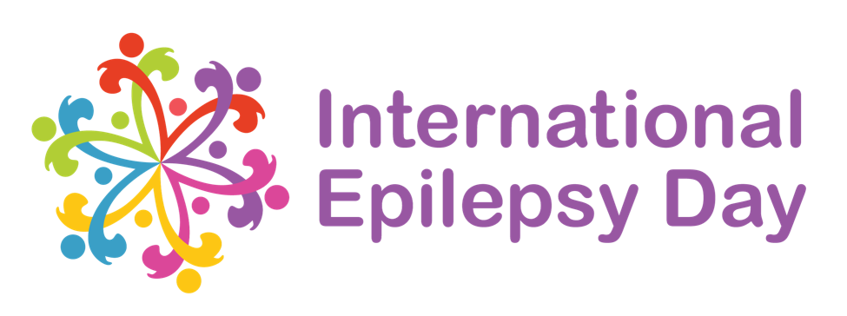

NEWS RELEASE
February 2021

International Epilepsy Day marked around the world!

International Epilepsy Day is a global event celebrated annually on the second Monday in February, to promote awareness of epilepsy around the world. This year it takes places on Monday, February 8th.

Epilepsy is a neurological disorder which affects the brain. It is a tendency to have repeated seizures. It is estimated that 65 million people are living with epilepsy around the world.

[Organisation name] will support International Epilepsy day here in [country or region] by [insert event details]

[insert organisation representative’s name], [insert organisation representative’s title], explained the importance of raising epilepsy awareness:
[insert representative’s quote]

On February 8th people are encouraged to share photos, videos or stories on social media with the hashtag #EpilepsyDay, and can see posts shared around the world via an interactive map on the International Epilepsy Day website – www.internationalepilepsyday.org.

For information about epilepsy support in [your country or region] visit [organisation website]

