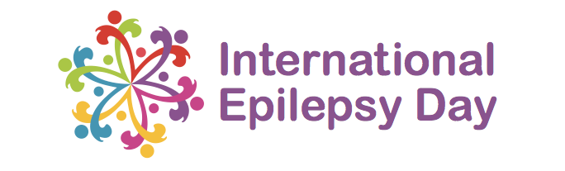

  - Please help us translate our International Epilepsy Day resources into your language.
Complete the translations below and return to annlittle@ibe-epilepsy.org.

Poster/Graphic 1

Save the Date!
[add your translation here]

Monday, 8 February 2021
[add your translation here]

International Epilepsy Day
[add your translation here]

Epilepsy is more than seizures
[add your translation here]

Poster/Graphic 2

Epilepsy is more than seizures, and so are we!
[add your translation here]

On International Epilepsy Day we're asking everyone to raise awareness by sharing a photo with the #EpilepsyDay hashtag.
[add your translation here]

Poster/Graphic 3

Let’s shine a light
[add your translation here]

For epilepsy
[add your translation here]

This International Epilepsy Day we're asking you to encourage landmarks in your town or country to light up purple -
[add your translation here]

let's shine a light on epilepsy!
[add your translation here]

