EPILEPSY ASSOCIATION OF SIERRA LEONE (EASL)
INTERNATIONAL EPILEPSY DAY CELEBRATION REPORT
THEME FOR THIS YEAR’S CELEBRATION: INCLUSION AND FRIENDSHIP

FEBRUARY 10th 2020

BACKGROUND TO THE REPORT
2019
The International Epilepsy Day (Monday 10th February 2020) seeks to raise awareness and educate the Sierra Leonean public facts about epilepsy and the urgent need for adequate and accessible medication, proper management, and greater understanding of the condition. The Internal Day provides a platform for people with epilepsy to share their experiences and stories with a global audience and encourages people with epilepsy to live to their fullest potential. Despite being one of the world's oldest known medical conditions, public fear, and misunderstanding about epilepsy persists, making many people reluctant to talk about it.
That reluctance leads to lives lived in the shadows- Women and children are the hard hit in many situations. Children are being asked out of schools; women raped or abused discrimination and stigmatization in places of work and communities.
EASL marked this year’s international celebration with series of awareness raising activities including Television and Radio talk shows, conferences in the three hubs (Freetown hub - Freetown, Kabala hub - Magburaka and Bo hub- Kenema). The meetings started in Magburaka- Tonkolili district, Kenema and then Freetown. EASL brought together key stakeholders from different sectors- education, District Health Medical Teams; partners- Local Council, Social Welfare etc. The meetings also created platforms for stakeholders and policy makers to give assurances and commitment to support persons with the condition and increase government attention to epilepsy issues.
The aim of commemorating the Day is to create the platform for persons with epilepsy to share their testimonies with community, national and global audiences and to encourage key stakeholders to make commitments that will see the transformation of the lives of epilepsy persons

ACTIVITIES UNDERTAKEN BY EASL IN MARKING THIS YEAR’S CELEBRATION
- AWARENESS RAISING THROUGH MEDIA.
Professor Lisk, Max Bangura, and other personnel held radio and TV discussion programmes and had interviews with journalists on not only the importance of the day but also answering questions on the challenges and ways of improving the lives of persons with epilepsy and the need for a concerted effort to stop discrimination and intensify support for victims.
They engaged National, regional and community radio and television stations:
- SLBC, AYV, 98.1, Citizen, Tumac etc in Freetown;
- SLBC Magburaka, Radio Maria
- Radio Nongowa, SLBC Kenema)
More than 13 radio discussions were held; 15 interviews conducted; participated in 4 TV programmes (SLBC, AYV, FTN). The radio discussions and TV programmes were repeated in the different stations. Key newspapers like the Awoko, Politico also covered our activities with publications on key messages about epilepsy

Mr Max Bangura – Executive Director and Founder of Epilepsy Association of Sierra Leone
Prof Radcliffe Lisk - Consultant Neurologist &Coordinator National Epilepsy Programme

2.0 conferences held in Kabala Hub (Magburaka), Bo Hub (Kenema) and Freetown Hub in Freetown
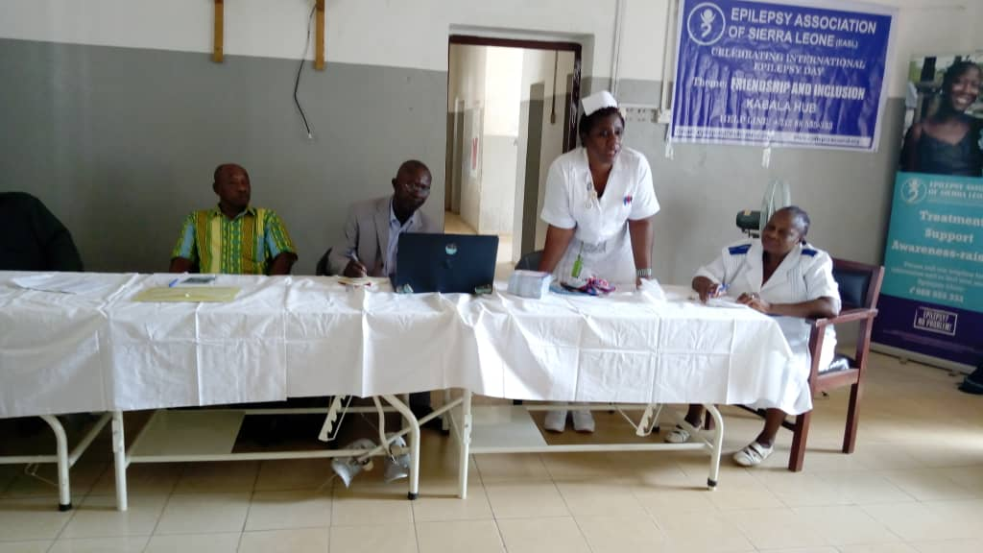
- MAGBURAKA CONFERENCE
EASL started this year’s celebration in the Northern part of Sierra Leone (Magburaka in Tonkolili District) on the 3rd of February 2020. Very prominent stakeholders were invited to grace the occasion - Matron Maseray of the Magburaka Government Hospital, Mr Sheriff from the Ministry of Social Welfare, Representatives from Council and Education; Imam, Pastor and one prominent personality from the township – Mr DK Jalloh as key note speaker. Many patients and caregivers also attended.
The meeting started with prayers and introduction of members of the high table and the chairman. 62 persons attended the conference (17 male; 27 female and 18 children)
CHAIRMAN OPENING STATEMENT
Mr Thomas S. Bangura the Chairman also the Principal of Sierra Leone Muslim Brotherhood Secondary school, a member of the Sierra Leone Teachers Union and Former Councillor thanked all the important stakeholders present and appealed to patients and caregivers to feel free and share their experiences with them. He told the gathering that school authorities and community stakeholders should do everything possible to stop discrimination of pupils with epilepsy in schools and others in communities. This he maintained will create the right environment for learning and integration. He ended by appealing to stakeholders to do everything possible to protect epilepsy patients so that they will continue to have hope.
STATEMENT BY THE MATRON – MAGBURAKA GOVERNMENT HOSPITAL
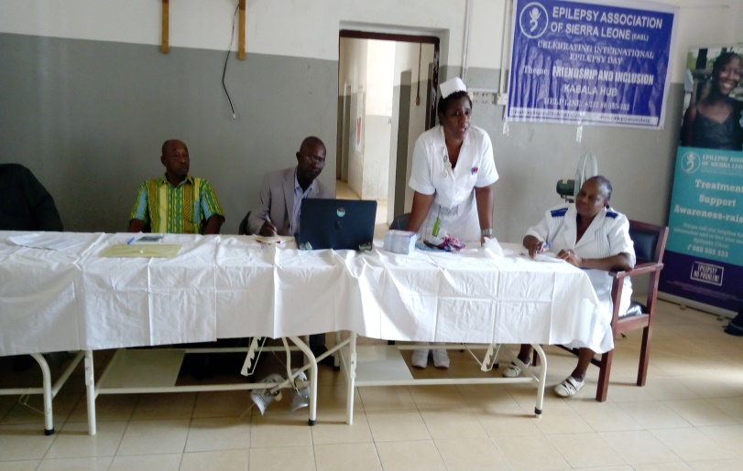
Sister Maseray T Kanneh, the Matron of Magburaka Government Hospital also thanked key stakeholders for leaving their busy schedule to attend the meeting. She told patients that epilepsy can be controlled by medication. The Matron admonished caregivers to pay attention to patients stating that they are not lunatics, witches nor possessed by demons. She went on to say that patients should be courageous, mentioning that there are people with autism and other forms of disabilities that are in a worst situation than them.
Finally she cautioned them against going to traditional healers but should rather take all epilepsy cases to the hospital.
The Sister affirmed the District Medical Health Officer commitment to collaborate with EASL, Stakeholders and traditional healers to combat stigmatization and discrimination of persons with epilepsy. She also assured patients that the Magburaka Government hospital and PHUs are always open to patient with epilepsy and their families.
STATEMENT BY MR SHERIFF FROM THE MINISTRY OF SOCIAL WELFARE
The Social Welfare representative Mr Alhaji F Sheriff thanked EASL for complementing government’s efforts and for the intervention to combat epilepsy in Tonkolili district by debunking the myths associated with the condition.
The representative maintained that it is the right of persons with disability to access medication and other amenities but have faced challenges. He admired the Theme for this year’s celebration – “friendship and inclusion ” affirming that for a very long time persons with disabilities have been excluded in all spheres of life- education, community activities etc. It is good that the IBE and the ILEA has set aside a day for persons with the condition to come out and give testimonies he said. He concluded by advising participants to join hands and spread epilepsy messages- that the disease is not transferable. He assured participants of the Ministry’s support to especially partners like EASL that worked hard to improve the welfare of Sierra Leoneans.
STATEMENTS were also delivered by Pastor Peter Turay and Sheik Abdul Bangura. Each of them emphasized the need for followers to give support to persons with epilepsy. This they believed is in line with religious teachings of ‘Love one another’. They reiterated their pledge to continue the referral of epilepsy patients to nearby health centers for medication. They conceded that indeed epilepsy can only be controlled by medication and proper care.
STATEMENT BY THE MENTAL HEALTH NURSE
The mental health nurse at the Magburaka government hospital, Madam Isatu Charm thanked EASL for the support in medication and the social services. The nurse narrated the challenges she has been facing in dealing with patients. That some of the patients came to the hospital without a single cent and she has to buy drugs for them seeing their deplorable conditions. She appealed to stakeholders especially the matron to advocate for the free supply of epilepsy drugs to the hospital and other Health units in the district.
Madam Charm also encouraged patients to continue taking their medication and come to the clinic on the scheduled date.

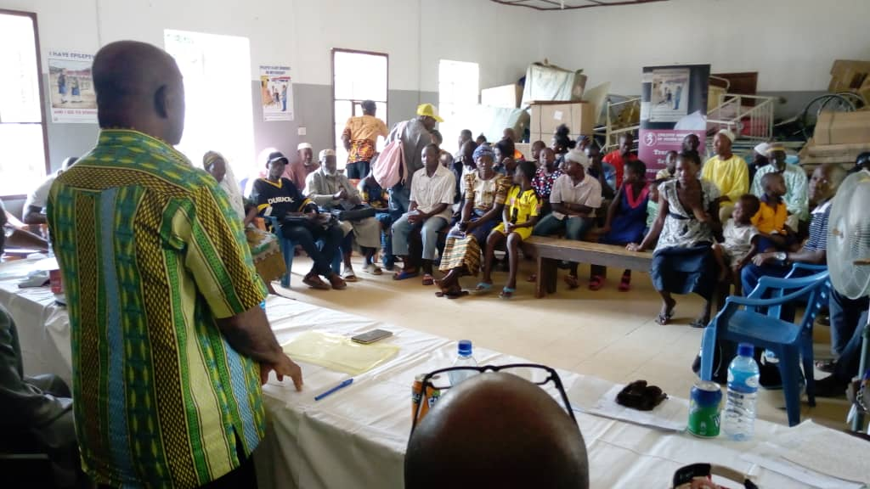
STATEMENT FROM THE KEY NOTE SPEAKER
The key note speaker, Mr DK Jalloh spoke lengthily on the roles of the different stakeholders present, and admitted that efforts have been made by EASL to alleviate the plight of persons with epilepsy in the district, but that more needs to be done especially by stake holders- DHMT, Council, and even Social Welfare to address discrimination and stigmatization at every quarter and community or institutions. He told participants that school children have not been spared at all. Many have been asked out of schools by teachers because of their condition, this he warned must stop. He called on the school authorities to continue on the advices given by EASL so that pupils will stay in schools.
Mr Jalloh stated some of the causes of epilepsy including harmful drugs, accidents etc. He also pointed that epilepsy is not caused by demons or witchcraft nor is it transferable. He appealed to all to cascade epilepsy messages in every corner of the district using every available channel.
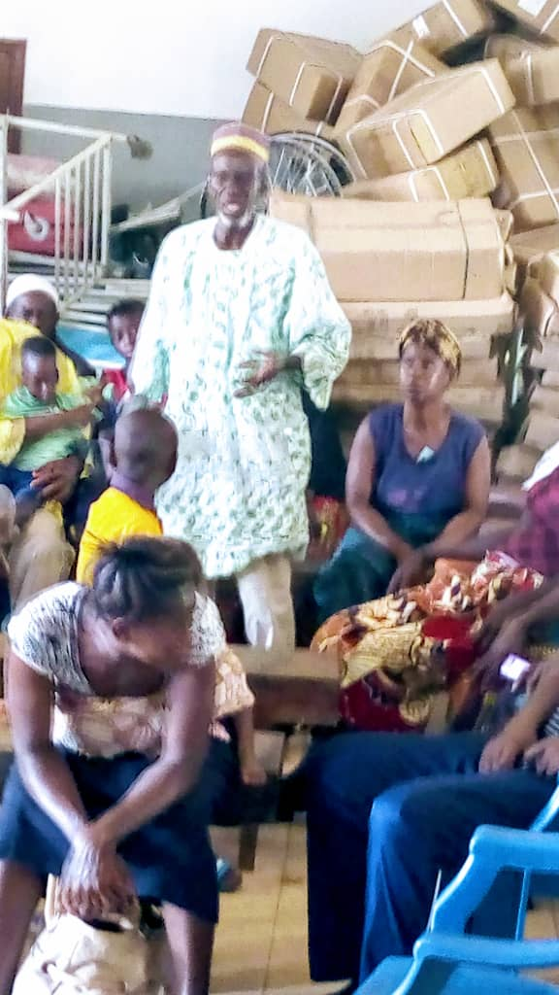
FIRST TESTIMONY BY MR SAMUEL TARAWALLY, A CAREGIVER
Mr Tarawally told participants that when his daughter Memunatu started having seizure, everybody in the neighbourhood advised him that she is seeing a demon. That the way she behaves during seizure is a clear sign that the child is having a demonic attack. He narrated how he had spent two years moving from one village to another; from one herbalist to another. In the process spent huge sums of money as payment and buying sheep and other materials used for the traditional cleansing. Unfortunately, there was no change, as a matter of fact situation exacerbated last year when his daughter nearly died during fumigation. They had to rush to the hospital to save her life. At the end of the episode, the doctor asked me what had happened, I explained and he sent for the nurse who happens to be Nurse Adam by then (mental health nurse). Since then Mr Bashiru Kargbo the Epilepsy Support Worker visits my home frequently to check on her condition, gave me words of advice especially with regards to medication and care taking he said. He thanked the organization for the support and boasted that he will always listen to the advice of the nurse and Bashiru Kargbo.
Two other care givers – Mrs Isatu Kamara of Masoko Village and Kadiatu Koroma of Rowala Village gave similar testimonies. Each of them narrated the cruelty they went through at the hands of medicine men (Traditional healers). They told participants that they spent huge sums of money even to the extent of cloths, goats to pay for the treatment. The two caregivers also informed all that neither the traditional healers nor their medicines helped them. It was only when they came in contact with the Epilepsy Association of Sierra Leone (EASL) through the nurses that they saw improvements. Madam Isatu even said her child has taken over a year without having any recurrent seizure. They admonished others to comply with medication.
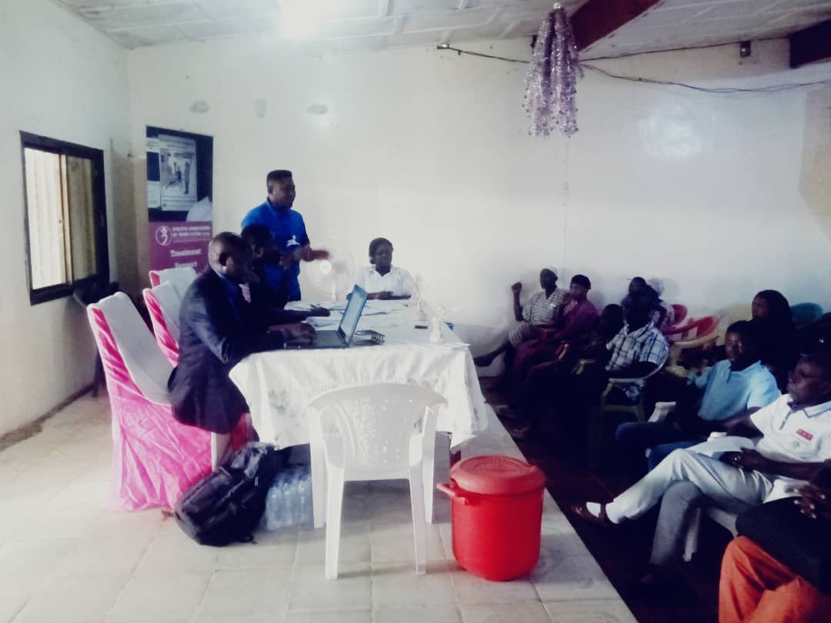
- KENEMA CONFERENCE
The Conference took place in the Eastern Province of Sierra Leone on the 5th of February 2020 at the Chibuzor Entertainment centre in Kenema town. Key stakeholders including District Health Management Team (DHMT), Mental Health Coalition rep, Religious personalities a representative from the Teachers Union, and Health personnel from the Correctional Centre in Kenema were present.
Prayers in the Muslim and Christian faiths preceded the meeting followed by a brief introduction of the stakeholders present.
In his opening statement, the Chairman of the occasion Mr Ibrahim Feika thanked EASL and all those who have left their busy programmes and offices and even the pupils, who have all made it a point of duty to attend such an important conference. He stated that it is difficult to be a chairman of an occasion where we have very important people in attendance. He called on Mr Turay of EASL to explain the purpose of the conference.
PURPOSE OF THE CONFERENCE BY EASL PROJECT OFFICER
The Project Officer thanked the chairman for the opportunity given to him, the purpose of the conference he said was to celebrate the International epilepsy Day which is held on every second Monday of February. He told the gathering that the day was set aside so that people with epilepsy will share their experiences with a larger audience on various platforms; share testimonies with community members because they have a lot of stories to tell, successful stories too. He went further to say that a lot of patients have gone through traditional treatment which is often characterized by torture. He further maintained that the day captured key stakeholders to pledge their support to persons with epilepsy after hearing to their stories and plights.
STATEMENT BY MR FRANCIS A SUMA, THE DHMT REP
Mr Suma in his address reiterated the importance of this day, noting that the disease is misconstrued by many to be a traditional illness. He informed participants that the disease is a medical condition and that people/caretakers should show love and care for persons living with epilepsy. He maintained that persons living with epilepsy should be given the rightful support. Parents and caregivers should not encourage patients to go to the waterside or cook on open fire alone in order to avoid accidents.
He admonished persons with the condition to take their treatment seriously and heed to the advice of social workers as medication and care giving works hand in hand. He said his department is now working with the ESW on the ground to undertake joint monitoring, awareness raising campaigns and data collection in the district.
STATEMENT FROM THE MENTAL HEALTH NURSE AND KEY NOTE SPEAKER
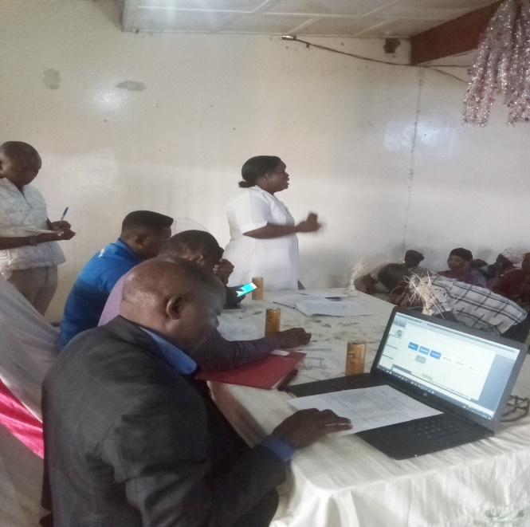
The Mental Health Nurse- Madam Hawanatu Foday expressed her happiness about this day as it brings together patients and stakeholders and raise awareness about the disease. She said most times persons with epilepsy do think that taking their drugs just once would control their seizures forgetting that it is a chronic disease.
She said epilepsy needs prolonged treatment and advised parent and caregivers to encourage persons living with epilepsy to take medication seriously. Madam Foday emphasized the importance of sending children to school or institutes saying they have the same rights like others. She mentioned a woman called Hellen Keller who was deaf, dumb and blind but yet able to acquire a Bachelor’s degree. She again expressed satisfaction in seeing different patients and encouraged them to accept their condition and comply with their medication.
STATEMENT BY THE HEALTH OFFICER, SIERRA LEONE CORRECTIONAL SERVICES (SLCS) KENEMA
The health personnel at the Sierra Leone Correctional Services in Kenema, Mr Musa Bangura expressed his gratitude to the organizers for given him the opportunity to attend such an important event. He said that collaboration between the Services and EASL was very timely and has benefited the inmates a lot. He told participants that over the years inmates suffering from epilepsy faced many challenges in terms of access to medication and social services.
The health officer said the intervention of EASL has ensured access to medication for inmates through the mental health nurse. He said 4 inmates are currently having epilepsy at the SLCS Kenema.
He appealed to the organization to provide legal representation to persons living with the condition for a speedy trial or other support.
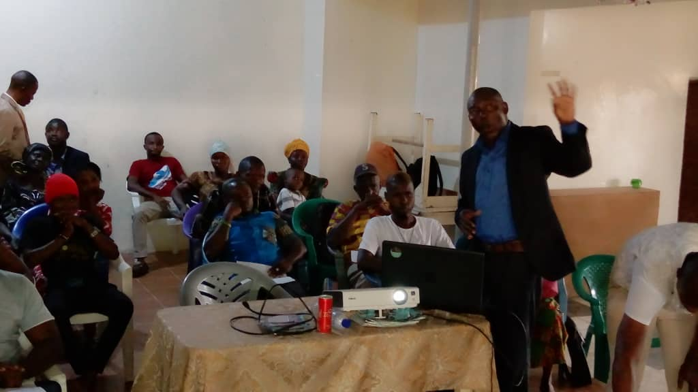
PRESENTATION BY THE EXECUTIVE DIRECTOR ON TRADITIONAL BELIEFS
The EASL Director (Mr Max Bangura) thanked the chairman and told participants that his presentation would be for only two minutes because he wants to give opportunity to patients to talk since this is their day.
He said the name given to the disease epilepsy differs from one ethnic group to another. The Creoles call it ’fits’ they called it “fix” because for some people during seizure they will steer or fix their eyes at a particular place. So they say the disease resembles that person that steers. The Themnes call it “katuk” as it in giving injection. The Themnes compare a person’s behaviour during seizure to that of a person taking injection. They said the disease resembles a person taking injection so they call it “katuk” (the injection) The Limba called it “makendor” means the monkey. The monkey’s clinching of fist during roasting is compared to a person fallen down with a fist and teeth clenched. The Mende called it “Gbongborni” because of the way a person knocks his or her head on the ground during seizure. I want to tell you that epilepsy problem is with the head. This shows that epilepsy has been in existence for a long time. But the good news is that it is a medical condition he paused.
He reminded participants that a lot of people with epilepsy have passed through numerous shame and exclusions. Sometimes traditional healers come to the conclusion that a person has epilepsy after one seizure, but this is not so the Director said. He told them that there are different types of epilepsy and the kind of epilepsy a person has is determined by which part of the brain that has sustained an injury. He observed that many patients have passed through trial times so this is the time to share with us your ordeals. Some people have sold all what they have because of this condition.
Families have spent large sums of money on traditional healers to try to cure epilepsy. Some have gone through dangerous treatment which has resulted in long term health complications and shame. He also made mentioned that women find it very hard to find a partner and often don’t have a family of their own. School children are asked to go home and seek medication and never returned.
He encouraged them to be happy; this is the day to say thanks to God. Participants sang a song in Krio titled “Tiday na mi yone day”, TODAY IS MY DAY
TESTIMONIES

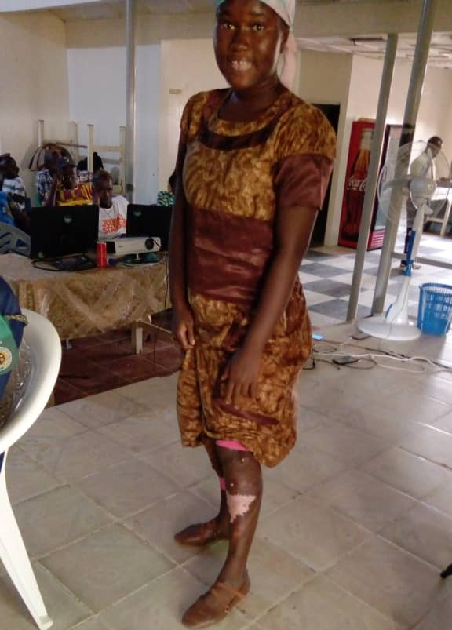
TESTIMONY OF JULIANA T DAVIES
Juliana was in class 3, attending the Holy Rosary Primary school when she had he first attack. She was immediately taken to the church where a pastor prayed for her. This she said was explained to her after the attack. Few weeks later the attacks/seizures became frequent. Her parents took her this time to a traditional healer for medication, but after weeks with the traditional medication, nothing changed she told the gathering.
They returned to Kenema few days later after and had like two weeks without seizure, and decided to go to school. One Thursday morning she had a seizure right in front of the assembly. Later the head teacher asked her to call her mother. I don’t know what they discussed but my mother told me later that I will not be attending school again until my condition improves. This was how I left school.
My mother was discouraged and asked me to pray fervently. I go to the church morning and evening since that day. Sometimes it will appear that things are working but seizures will come again. One afternoon, I was cooking at the back of our house when I had seizure. I burnt my leg before I was rescued. I was then taken to the hospital. My mother was asked to see one nurse who told us that I have the epilepsy. That was the first time that awful name was mentioned to me. I was then referred to the hospital where I started taking my medication and since then my health has greatly improved. I can now go out on my own to town. I can play with my friends, because Mr Issa the epilepsy support worker advised my mother during one of his visit that I should be playing with my friends. My mother has promised to send me to a vocational centre to learn tailoring. I thank God for the support I have received from the hospital and Mr Issa of Epilepsy Association of Sierra Leone.
MILLICENT MATTIA
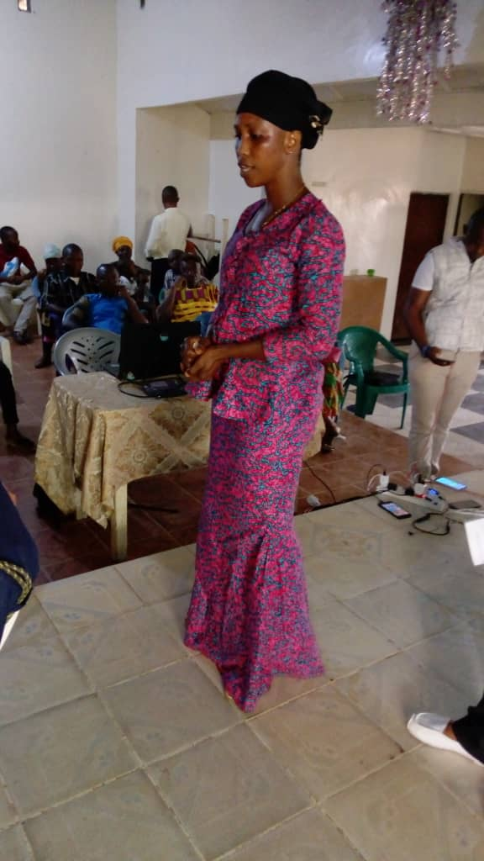
Millicent is now 18 years old but started having seizures since the age of 14, left Methodist Girls High School as a result of persistent seizures.
She told participants how she was badly treated by her mother. She said that her parents cared less about her, every morning she will go to neighbours to seek comfort. Millicent said her parents only cared about the other children. She said getting food to eat was difficult not to talk of medication.
She had about epilepsy treatment from a neighbour who admonished her to go to the hospital. She went to the clinic without money, explained to the Nurse about her problem. They felt sorry for her, gave her medication and Issa the social worker went home with her to see the parents and to discuss epilepsy issues. Since that day relationship with her mother got better, seizures controlled to sometimes only one time a month.
- FREETOWN CONFERENCE
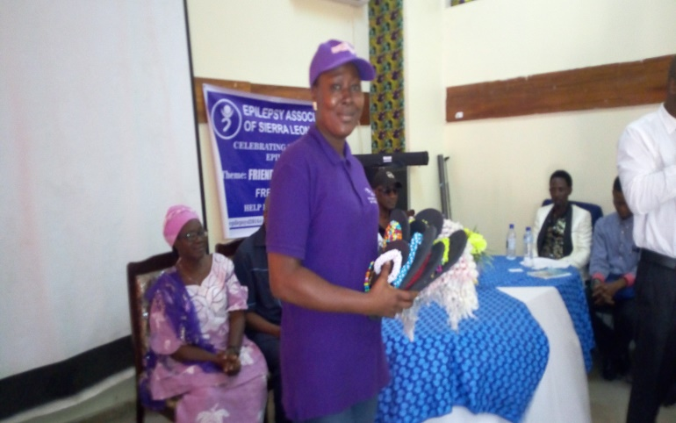
‘I will not assure you that epilepsy is curable but I will assure you that it is controllable’ Osman Kabia, Deputy Matron, Rokupa Government Hospital
Another conferences was heal in Freetown the capital city of Sierra Leone at the Sierra Leone Teachers’ Union (SLTU) Hotel 5-10 on Saturday the 8th of February 2020. More than 80 patients, caregivers, and key stake holders (Reps from Rokupa Government Hospital, Freetown city council, Sierra Leone Traditional Medicine Association, SLTU, Media houses, Board member etc) attended the conference. Other notable persons that attended were Professor Lisk and Dr Kadi Yillah.
Pastor Moses and Mr Amadu Bah led us in prayers in the Christian and Islamic faiths at the start of events.
CHAIRMAN OPENING REMARKS
The chairman (Mr Hassan Kamara) in his opening address thanked EASL staff and management for their relentless effort to support persons with epilepsy in schools. The Chairman narrated the challenges school authorities faced in managing epilepsy children in schools. He stated that epilepsy children have been discriminated, stigmatized and many were asked out of schools. The Chairman narrated events that precipitated the school authorities to start working with EASL. He thanked Mrs Gabbidon and the organization for the support given so far. He begged EASL to provide adequate epilepsy training for teachers so that they in turn will educate pupils.
STATEMENT BY PROFESSOR DR LISK
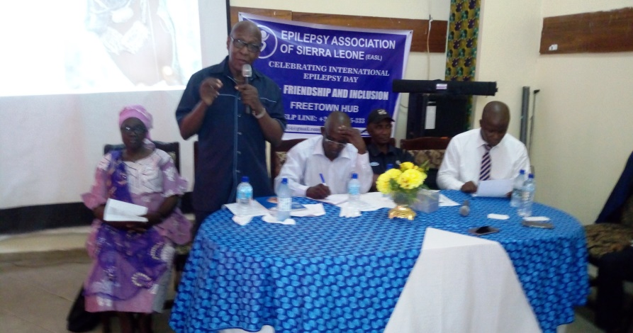
In his statement, Professor Lisk expressed satisfaction and happiness to hear that teachers are now fully involved in epilepsy activities. The Professor maintained that if teachers have the requisite knowledge about epilepsy, they would be in a position to cascade it to school children, who in turn will educate not only their peers but also members of their communities. He pointed out that teachers are vital in the awareness campaign and that it is important that epilepsy be included in the school curriculum.
The Professor admonished all present to take epilepsy messages down to the grassroots, that epilepsy can be controlled medically; there are medical centers nationwide to provide medication staffed with trained medical personnel/professionals. He posed two questions to patients and caregivers – ‘Is epilepsy caused by a witch or demon? The people answered no. The second question was – ‘Can epilepsy be transferred? Again the people answered no. Professor Lisk told patients and caregivers that the answers given were correct and that is very important if the fight against discrimination and stigmatization be won. He went on to say that the knowledge exhibited and will help in the referral process and in epilepsy management.
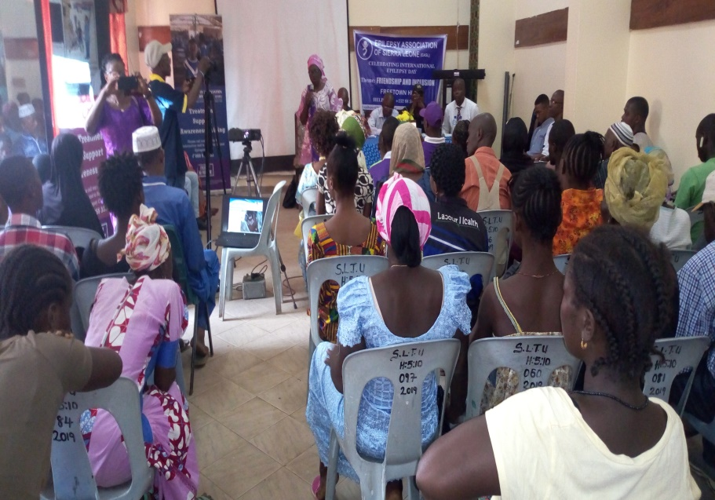
STATEMENT BY DR YULLA
Dr Yilla warmly greeted patients and other personalities present and thanked them for coming. She told the gathering that she works at Connaught hospital but supervises Rokupa, Lumely and Waterloo clinics.
The Doctor appealed to women to continue the good work of taking care of the homes, men, and children. She asserted that women are most likely to stand by men when in difficulties especially in the case of epilepsy. She however appealed to men to support women with epilepsy and other disabilities. She emphasized that women with epilepsy can also be educated and be a useful person in society. She again admonished women to take their medication regularly and follow all pieces of advice given to them by medical personnel and social workers.
STATEMENT BY THE COUNTRY DIRECTOR OF TRADITIONAL MEDICINES
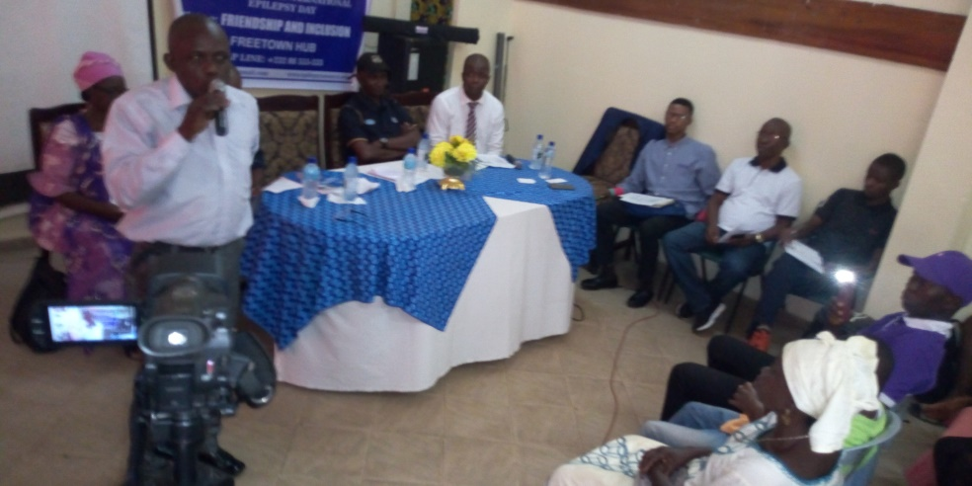
The country Director of Traditional Medicines Sierra Leone, Mr Abdul Bangura in his statement gave a detail account of people’s perception about epilepsy in the country before EASL intervention. ‘when I was a small boy I was told not to touch the spit/saliva of somebody with epilepsy’ he said. But my engagements with EASL has changed that narrative and now I know that epilepsy cannot be transferred even if I touch the spit or handle a person with epilepsy during seizure. He told participants that he met Mr Max Bangura during a high level Ministry of Health meeting, they had fruitful discussions about disabilities and of course epilepsy
The Director went on to say that perception about epilepsy cuts across all tribes in the country, that the myths about the disease are very strong in very remote areas of the country. He conceded that epilepsy people are still being discriminated and that some of his colleagues have treated epilepsy patients. But his organization has been having very fruitful engagements with herbalists not to treat epilepsy any longer, but to refer to the hospital, and that has had some positive results. Discrimination is high among our people so much so that sometimes when a woman has epilepsy others will tell you not to marry her’ because her epilepsy will transfer to you.
Mr Bangura added that women have lost their husbands, molested by even some unscrupulous medicine men as a result of this condition. He went on to say that sometimes even people with controlled seizures are discriminated to hold positions- like being councillors or honourable saying that they will have seizures in the middle of a meeting. He told the gathering that under the leadership of Mr Max Bangura they as traditional healers have been working hard to dispel or debunk those beliefs. He informed participants that the disease has medication. He admonished patients and caregivers to quickly take suspected persons to the hospital for prompt treatment because there are drugs available. He reiterated that the longer it takes to access hospitals the greater the risk of patients, sometimes resulting to fire accidents, drowning etc.
He concluded by saying that the Traditional Healers/Medicines Association will do everything possible to continue the referral of patients with epilepsy even in remote areas of the country.
Statement from the Deputy Matron, Rokupa Government Hospital
Mr Osman Kabia extended greetings from senior Matron of Rokupa government hospital to all participants. He said he is the deputy matron and he will speak on the clinical aspect of epilepsy. The mentioning of hospitals from previous speakers has made me very happy he said. Mr Kabia however, raised concern that some people are still with the belief that epilepsy is caused by demons or witch craft so as a result they shy away from health facilities and that they will choose to either go to herbalist or spiritualists. He told the people that epilepsy is a medical condition, that if they go to the hospital they will get the right treatment and they will recover. He said ‘I will not assure you that epilepsy is curable but I will assure you that it is controllable’
He assured all that the hospital is always open to all and urged them to make good use of the facility. He warned people to desist from nurturing the idea that epilepsy is caused by demon or witchcraft. He told people to overcome the fear and ‘break the silence’ that epilepsy is a medical condition; there are experts who are there to provide the right treatment he said. And more importantly people can return to their normal lives after treatment. He cautioned against stigmatization and pointing of fingers as this behaviour discourages people to mingle with us let us embrace them. He ended by saying that stigma and discrimination is responsible for people with epilepsy living in isolation
Other speakers spoke lengthily on the perception of people about the condition. Both the Pastor and the Imam spoke of the need for religious people to join hands with the EASL to sensitize others that epilepsy is a medical condition, that all should help to refer patients to the different health facilities.
STATEMENT BY MR ABDULAI TIMBO JALLOH- EASL BOARD MEMBER
Mr Abdulai Timbo an EASL Board Member, told the gathering that the Board has been working with the organization to push its agenda forward. He again narrated the beliefs of some people about what causes epilepsy; the discrimination persons faced in religious institutions, at home, schools and whatever environment they found themselves.
Sometimes discrimination is so much so that people circle any place where a patient had seizure he said. He went on to say that people with the condition are accused of having curses
Being a media person I have been sensitizing the people dispelling traditional beliefs/rumours about the disease even before becoming a Board member of EASL he told participants. He said epilepsy can be as a result of head injuries or other causes stated by doctors or health professionals. He implored all to ‘embrace’ persons with the condition. He commended EASL for running a skills training centre that caters for youths with epilepsy.

STATEMENT FROM THE KEY NOTE SPEAKER
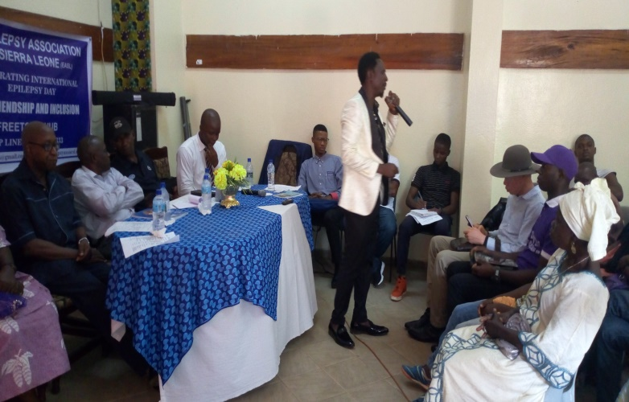
In his opening statement the Key note speaker, Councillor Sheku AG Turay who has acted as deputy Mayor of the Freetown City Council, sent greetings to all and registered his apologies for coming late saying he was attending to community matters. He informed participants that he has been a regular participant of epilepsy programmes. He maintained that the organization has been doing its best to support persons with epilepsy and for encouraging key stakeholders to support EASL activities nationwide.
Mr Turay thanked various speakers for their presentations and the different views – medical and religious aspect of epilepsy. He informed participants that he will speak from a community point of view as a representative of the community. The motto of Freetown City Council says “the welfare of the citizenry is the supreme law” This means that we have a role to play as a council to transform the lives of our citizens he said. He opined that community people also have a role to play to discourage stigmatization of these people. We are pushing away our people, as a result of discrimination and this has made them to stay away from the hospital he cried out. He said Sierra Leoneans have embraced Ebola Survivors before why not persons with epilepsy he asked? Epilepsy is not transferable like Ebola yet we don’t want to come close to them. He told participants that they all have a moral responsibility to cascade important messages about epilepsy that it is not transferable, not demonic or witch craft etc and we should embrace and treat epilepsy persons with respect.
The Councillor went further to that anyone can be a candidate of epilepsy at any given point in one’s life, ‘today is you, tomorrow it could be me’ he said. The speaker narrated a story of a tenant living now in America who gave birth to three children before she had epilepsy. He appealed for programmes that will cater for all like EASL is doing with the technical institute. Mr Turay also reminded patients of their responsibilities to help themselves stating that the ‘I don’t care’ attitude of patients towards medication is not helping; He admonished patients to take the medication as prescribed and on time.
He concluded with a slogan that says ‘being epilepsy patients is not our wish; not borne to be an epilepsy patient and we will fight against it’.
Stakeholders and participants said “”WE ARE COMMITTED” to fight against discrimination and stigma and patients to adhere to treatment
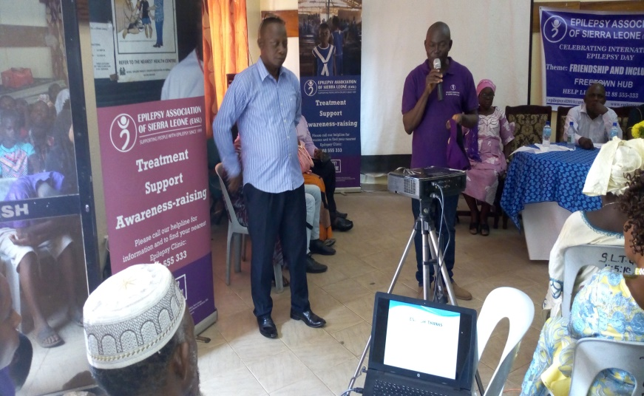
PRESENTATION BY THE EASL DIRECTOR ON THE TRADITIONAL BELIEFS AND THE IMPACT OF TRADITIONAL MEDICINES ON EPILEPSY IN SIERRA LEONE
The EASL Director, Mr Max Bangura thanked the chairman and told participants that his presentation would be for only two minutes because he wants to give opportunity to patients to talk since this is their day.
He said the name given to the disease epilepsy differs from one ethnic group to another. The Creoles call it ’fits’ they called it “fix” and other ethnic groups have different names for it. He displayed a slide showing someone with a seizure explaining that seizures and demonic attacks are manifested differently. He emphasized that epilepsy is epilepsy and has nothing to do with demon. He stated that even the epileptic drugs EASL gives are not enough at all. He informed the gathering that EASL has professional medical people and that his office takes care of the social aspect of the condition. The Director said the social aspect provides much needed information about hospitals, referral system, and sensitization about the condition. We debunk myths surrounding the disease using different strategies he said. The Director added that a lot of people have spent huge sums of monies to traditional healers without results, not until they come to the hospitals before things got better.
The Director asked if caregivers of epilepsy patients contracted the disease- they answered no. He maintained that it is clear evidence that epilepsy is not transferable. He added that if epilepsy is transferable many women should have contracted it now, because they come in contact with the spits much more than men because of their caring role.
Mr Bangura informed people that traditional healers are the first point of contact because of the perception that epilepsy is demonic. People would rather go to the traditional healer as first point of contact instead going to the hospital. He told participants that EASL has been working with some 475 registered Traditional healers in Koinadugu district. These people are known for their magical powers. EASL has trained these traditional healers to know about epilepsy and be able to refer persons with epilepsy to the hospital. EASL gave them business cards which they give to patients to go to the hospital.
The Director further explained the different traditional medicines given to patients – herbal concoction, urine to drink. That fumigation of patients has also been a routine which sometimes result to respiratory problems and accident. He displayed a picture showing fumigation and marking of persons with epilepsy with unsterilized objects.
He told them that patients who were involved with fire accidents are always being neglected. Traditional healers claimed that falling into the fire is a bad omen- the person will no longer be cured. He admonished people to be watchful and prevent patients from going to the river side/stream alone.
The Director informed patients and all present that EASL has a skills training centre that caters for youths and adolescents with epilepsy. He invited every youth and adolescent with the condition to the centre.
The Director concluded his presentation by highlighting the difficulties that women are facing at homes with their patients. The participants sang a song titled “Tiday na mi yone day”, TODAY IS MY DAY as was done in Kenema.
TESTIMONIES
1ST TESTIMONY BY ALIMATU KAMARA
In her testimony, Alimatu said she started having seizures when she was in form 2. Miss Kamara said she should have completed her education hadn’t it been for her condition. She left school because of her frequent seizures in class and been provoked by colleagues in class. I was attending Ahmadiyya Muslim Secondary School, but was asked out of the school, the Principal said I am demonic Alimatu told the audience and wept.
Miss Kamara gave an account of her ordeals at the hands of medicine men/traditional healers until somebody directed my mother to the Epilepsy Association of Sierra Leone where I currently take my medication. Things have got better now she exclaimed! Mr Max made sure that I learn a trade where I can earn a living and I now contribute to my family smaller bills and always make sure that I go for medication regularly. I always want to thank EASL for giving us the opportunity to learn skills at the LOVE institute.
2ND TESTIMONY BY Mr Amadu Koroma
Mr Koroma started his testimony with a song- “Something new in my life, something wonderful in my life, something marvellous in my life’’ He thanked the Almighty God for the improvement in my condition. I have known many ‘Murray men’ traditional healers, sacrificed sheep, spent money. I have travelled the length and breadth of this country even as far as Kabala in search of traditional medicines for my condition.
Today I am a ‘conqueror’ inside Max Bandura’s organization because, I have got treatment and things are currently getting better with my health and my community have once more accepted me. I will praise him and his team. Mr Amadu said he was a teacher before he fell ill, he had to abandon his profession in search of medication. Nevertheless I know that the Lord Jesus is with me he said. He agreed that epilepsy is a treatable disease and with the help of Jesus things will be alright not only with him but with others.
3RD TESTIMONY BY KADIATU SESAY
Kadiatu said she started school without the condition until she attained class 4 when she had the first attack during examination time. Miss Sesay told the audience that she was driven from the class and eventually from school, because I was accused of urinating on the feet of my teacher when I had the attack. Many of her friends deserted her, she said. Kadiatu informed the gathering that she started hawking to save money to go to another school. Unfortunately her mother would use the money she saved. Miss Sesay lashed out at her mother for her lack of care and concern, stating that her mother asks her to cook and fetch water on a daily base against the advice of medical officers.
All attempts made by my grandmother to convince her to take me to the hospital failed she said. So one day I left home and went to the hospital at Rokupa Kadiatu told participants. ‘I was treated nicely by the ; he gave me medicines and very good pieces of advice. I thank God now; I have not had seizure for over two months. Last month my mother followed me to the clinic and now helping me she concluded.

TESTIMONY BY MR SAMUEL WALKER
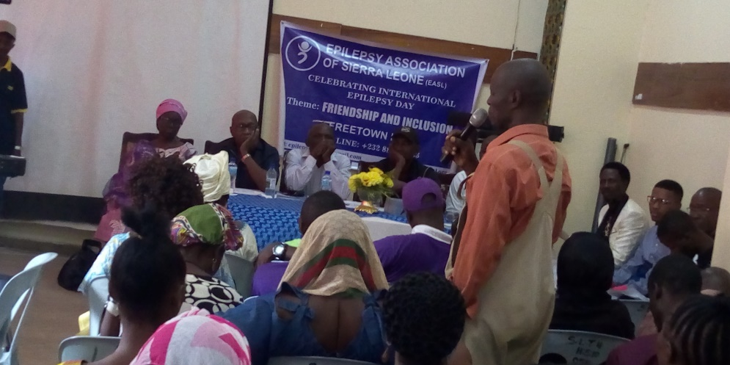
My name is Samuel Walker I work as a seaman. Mr Walker thanked his wife for taking care of his daughter saying that, things would have gone wrong if it where for her. He informed listeners that he is a seaman and has spent over Le 2,000,000 on his child (sierra Leone money).
Mr Walker narrated how he took his daughter to a traditional healer in a village, spent Le 1,500,000, and a cartoon of good fish. His wife Left the child in that village hoping that the disease would be cured. A close relative called to complain about the bad treatment his child was getting from the healers. He said he sent his wife again to bring back the child. Samuel conceded that women suffer a lot when it comes to care taking of a child with epilepsy. He told all how his daughter used to defecate everywhere in the compound, but his wife was there to clean up the mess. Mr Walker said he nearly gave up and decided to send the child to the ‘crazy yard’ – psychiatric home. The appalling thing that happened was when she got impregnated by a young man in the community. The hassle that followed that pregnancy prompted me to leave the area and transferred to my unfinished house in the village. Sincerely speaking if I had the chance I should have killed/ended my daughter’s life due to frustration.’ I tied my daughter one day’ but was redeemed by my friend he said. (Mr Walker nearly cried when he said these words)
That sad thought was saved when an old woman told my wife that there is an organization that will help. That was how I came to know about the Epilepsy Association of Sierra Leone. Thank God for that, because since she started taking the medication I have seen a lot of improvements, though she is still having ‘shocks’ he concluded.
VOTE OF THANKS
The Executive Director made some corrections to patients and caregivers referring to him as ‘Doctor’. He told patients that he is the Director of the Association, but has a responsibility to make sure that patients are provided with medication and social services at all times. He said the Rokupa centre has two Community Health Officers (CHOs) – Mr Martin Sesay and Mr Omar who are responsible for diagnosis and the dispensation of medication/drugs. He again told patients that Rokupa clinic is held every second Saturday of the month, admonished all to make use of the scheduled date to avoid problems.
Delivering the vote of thanks He thanked God for the success the Organization has made in debunking the myths surrounding the disease saying that today many people are now coming out of isolation. He thanked also Pastor Moses for his counselling work with patients and caregivers with the message of not to give up.
He thanked Professor Lisk and Doctor Kadi Yullah for attending; he acknowledged that there are other Doctors but could not make it due to some busy work schedules.
He also thanked Mr Bangura (the President of the Traditional Medicines) for coming though it was not easy to convince him to come for the meeting. We always want to work with them as mentioned earlier they are the first point of contact when someone has epilepsy. The Director was hopeful that EASL will soon have a project that will provide more training for traditional healers.
He extended appreciation and thanks to the Matron, and appealed for sustained partnership with the hospital in area of training and referrals. He thanked the Chairman and the keynote speaker for a job well done. The meeting ended.

