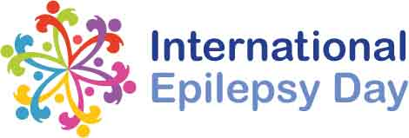
INTERNATIONAL EPILEPSY DAY
4 CME
9 February 2017
8:00am to 12:00pm
Hajar Auditorium, HMC Education Center

TIME | TOPIC | SPEAKER
8:00am-8:10am | Welcome | Boulenouar Mesraoua
8:10am-8:30am | Social aspects of epilepsy in Middle East | Hassan Al Hail  (President of QLAE)
8:30am-8:50am | What is it like to live with epilepsy?-  patient’s view | Yasser Othman
8:50am-9:20am | Driving and Employment in Epilepsy | Boulenouar Mesraoua
9:20am-9:40am | How to minimize side effect of AED drug in epileptic patients | Gayane Melikyan
9:40am-10:00am | Living with a child with epilepsy | Khalid Ibrahim
10:00am-10:30am | Management of epilepsy in female | Dr Nabil
10:30am-11:00am | Why there is stigma in epilepsy? | Clonzalo
11:00am–11:30am | Seizure percussion and first AID | Basim Uthman
11:30am-11:50am | Surgical and non-Surgical treatment of epilepsy | Naim Haddad
11.50am-12.00pm | Ordination for EMU admission | Abdul Raheem
12.00pm-13.00pm | Closer | Hassan Alhail

