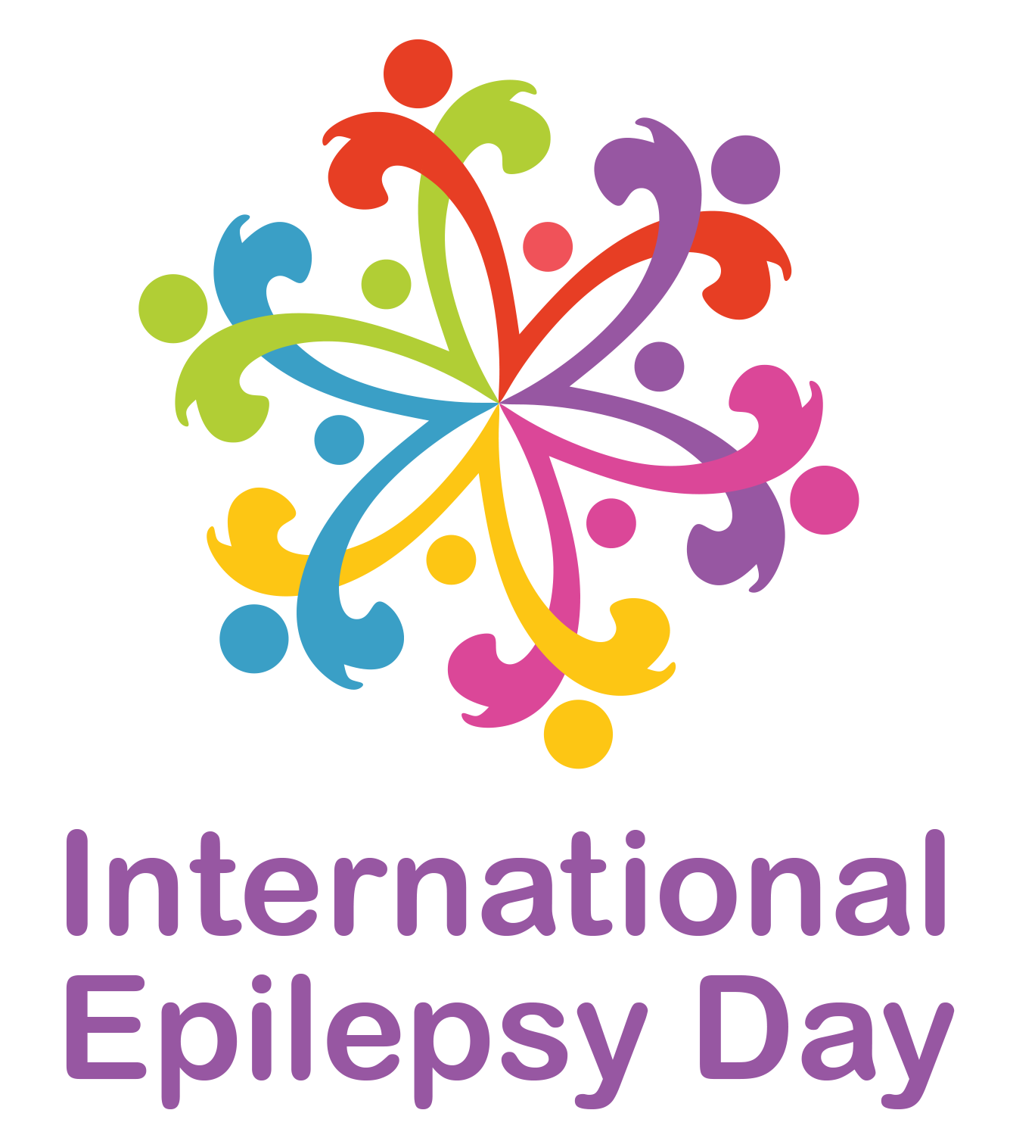
PUTTING EPILEPSY IN THE PICTURE
Art Competition for International Epilepsy Day 2017
ENTRY FORM

Given Name: __________________ Family Name: _________________________
Address: _____________________________________________________________
Country: __________________
Email address: _____________________________________________________________
Age (if under 12 years): ______
Title of Entry: _____________________________________________________________
Category (place an X next to the appropriate description below):
Painting or drawing
Photo montage
Multimedia artwork
Pottery
Sculpture
Beadwork, embroidery or needlework
Video
Music
How does your entry reflect the theme of the competition – Putting Epilepsy in the Picture? (To be completed by competition entrants 12 years of age and older. Maximum 50 words)
Type here
By placing your name on the signature line below (or that of a parent or guardian in the case of an entrant aged under 12 years or who is unable to write or type their name) you confirm that you have read the rules of the competition and that the competition entry abides by those rules.
Entries must be submitted to ibeexecdir@gmail.com before the deadline of 31st December 2016. No late entries will be accepted.

Signature: _____________________________________________________________
(type name or insert electronic signature)

